2. Construction

2.1 Database Design

2.1.1 Database Web Server
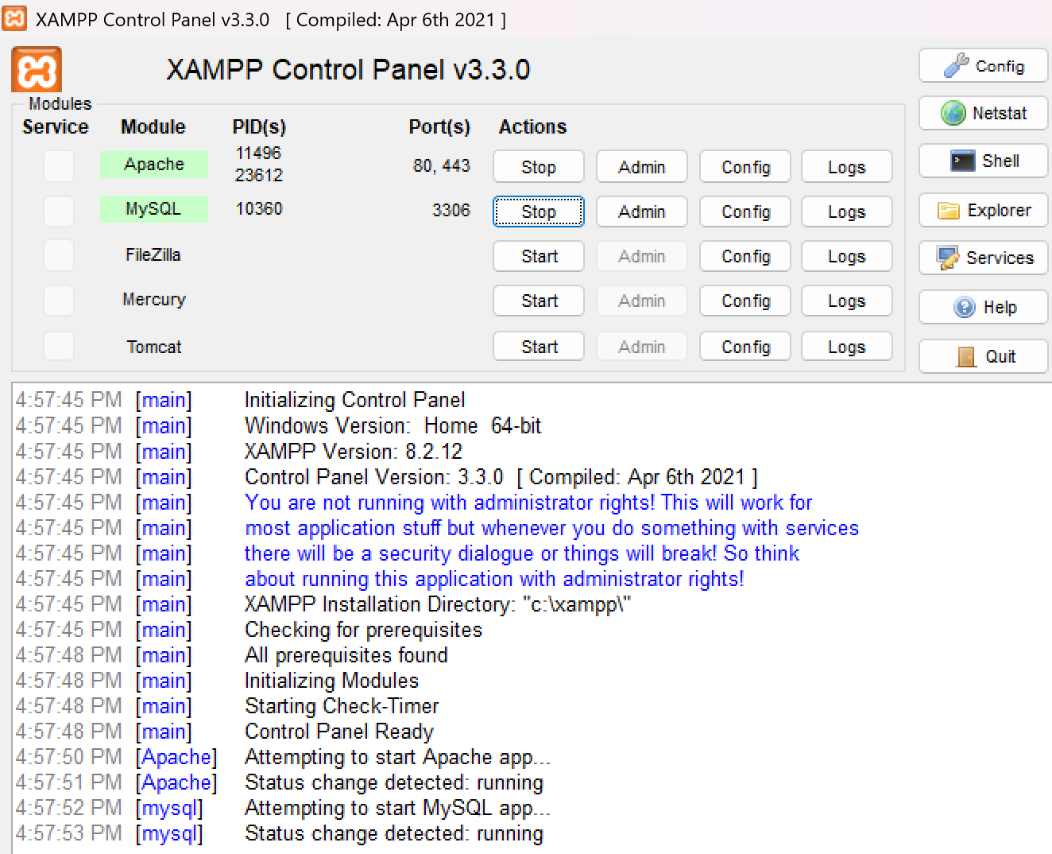
Fig: Database Webserver

2.1.2 Database Structure in phpMyAdmin

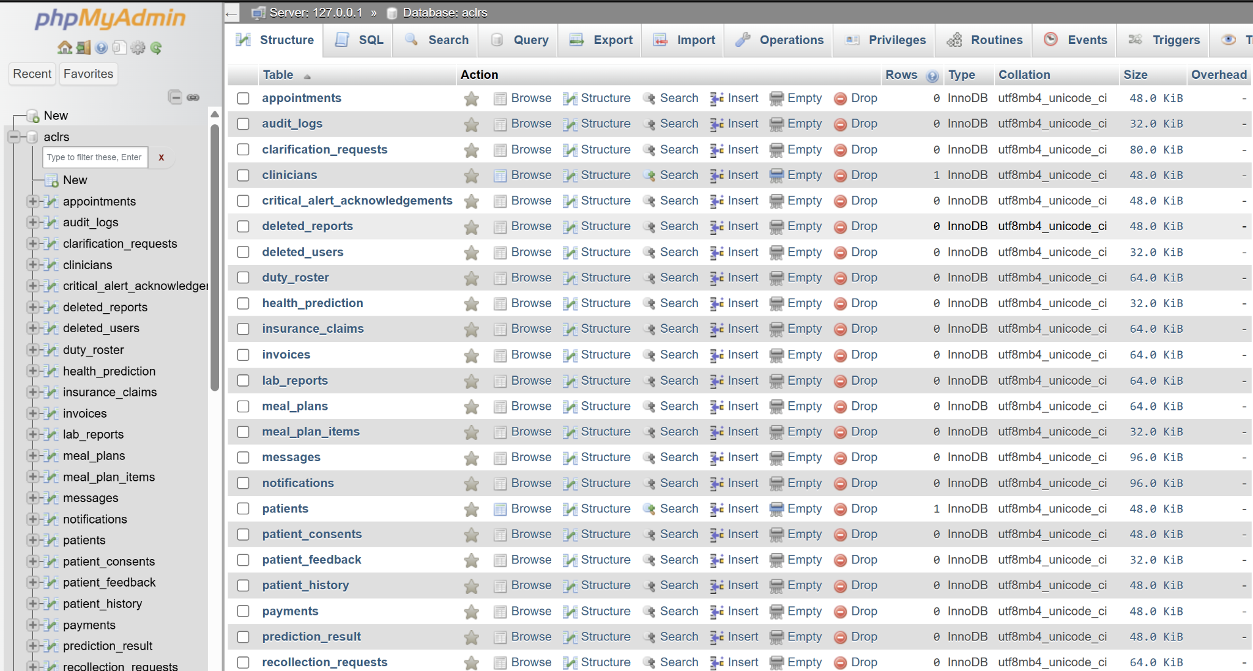
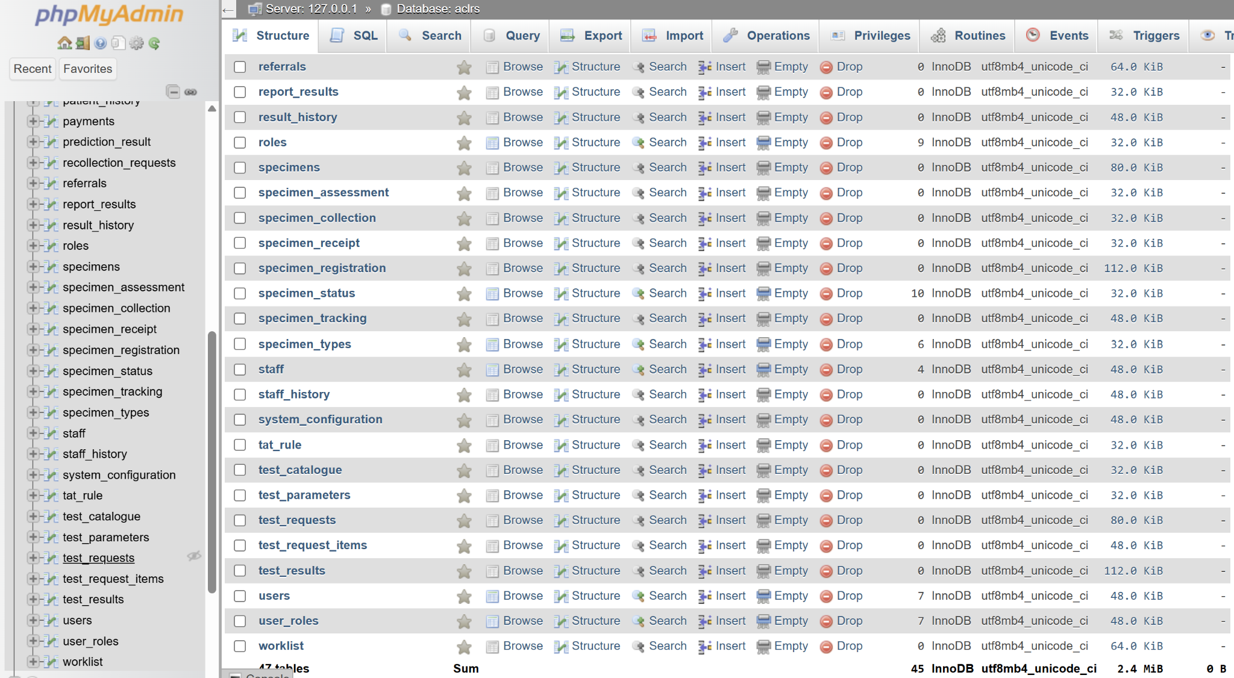
Fig: Database structure in ACLRS

2.1.3 ACLRS Database Design
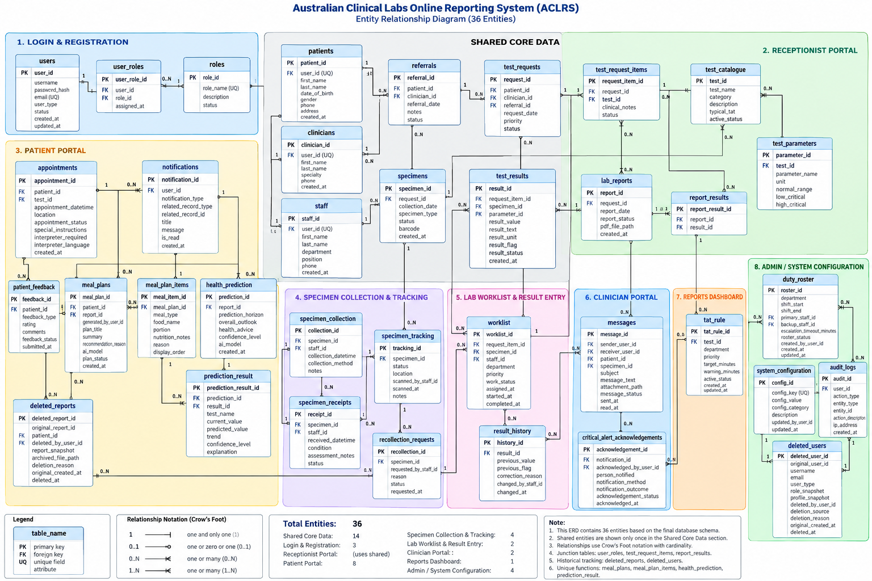
Fig:Database design of ACLRS

